FIRSTHAND LOTHIAN
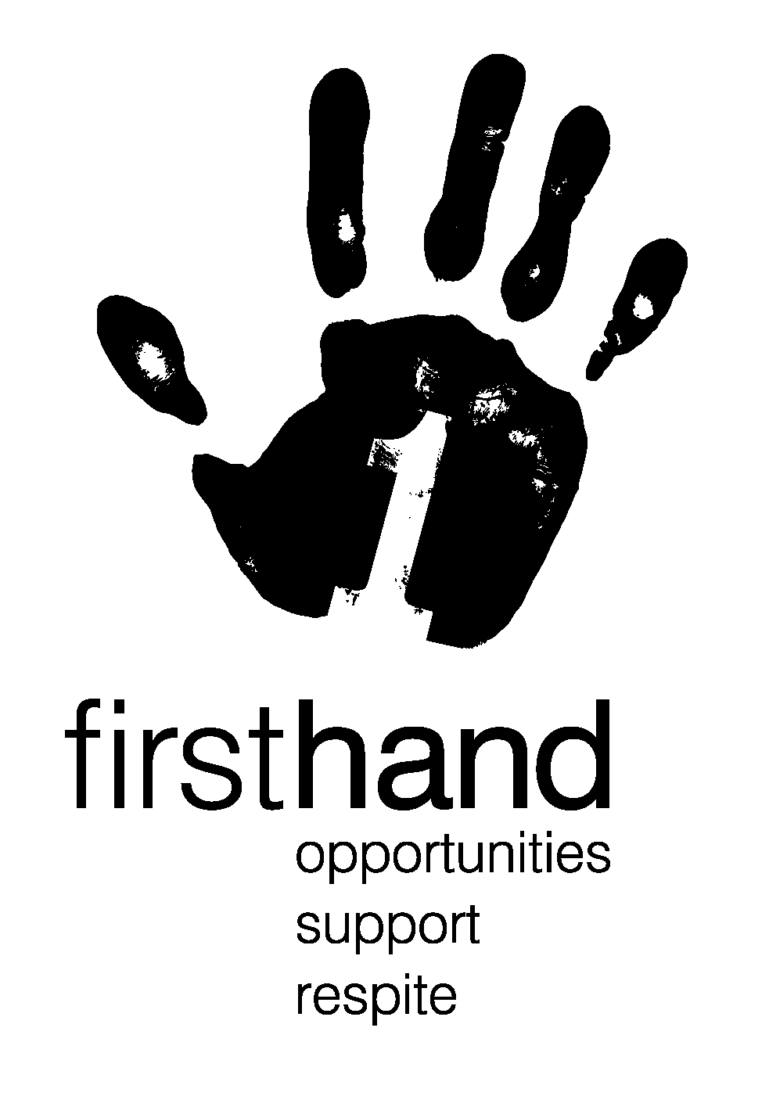

Volunteer Application
Please return the application to: info@firsthand-lothian.org.uk
Alternatively you can post to: - Firsthand Lothian, Strathmore, 8b McDonald Road, Edinburgh, EH7 4LZ

Date of Application Full Name Date of Birth
Click here to enter a date.

jkxcj

Current Address

Telephone Number Mobile Email address

I am interested in supporting (please tick one) ☐ Child/Young person ☐ Parent /Carer

Why are you interested in becoming a volunteer with Firsthand Lothian?
What would you hope to gain from the experience?

How /where did you hear about Firsthand Lothian? Are you a member of the PVG scheme?
Yes ☐ No ☐ Don’t know ☐

We try to match all volunteers who meet the requirements as stated in the Role Description. Please tell us about any issues, health or otherwise that we need to consider when matching you with a family or young person.

Do you prefer interview by phone, meeting in person, zoom? Do you have any other requirements for interview?

Statement on General Data Protection Regulation (GDPR) 2018
Thank you for giving us information about yourself. Because some of this information is sensitive under GDPR 2018 and Data Protection Act 1998, we ask you to sign below to consent to Firsthand Lothian recording your data. If you are uncertain about this, please do not sign immediately, and a member of staff will talk about it with you.
We will ask for further information from you while processing your application, and from time to time after that in order to match you with a parent/carer/ child/ young person.
Personal data is also kept on a spreadsheet which is backed up on our secure I.T. server. Electronic information can only be accessed by office-based staff and access is password protected. We will not pass on personal information regarding your to any other person or organisation without your permission, unless we consider that someone’s wellbeing or safety is at stake or we are required by law.
Your Personal data is kept for 6 years after the arrangement is finished. It will then be disposed of in our confidential waste. We will retain details of your name, date of birth, start and end dates with FHL electronically for up to 6 years in case you require a reference in the future. We ask you to help keep the information we hold accurate by informing us of any changes.

I have read and understand the Statement on GDPR and Data Protection and consent to Firsthand Lothian as Data Controller keeping personal data about me on these terms. Tick one or the other Yes ☐ No ☐

Declaration: I declare that all the information given on this form is correct and complete to the best of my knowledge and belief.

Name Signature Date
Click here to enter a date.

Firsthand Lothian is recognised as a Scottish Charity No SC020655. Firsthand Lothian is a company limited by guarantee registered in Scotland No. 140769 Registered Office: Strathmore, 8b Macdonald Road, Edinburgh, EH7 4LZ


