

Autism in the Pre-School Years

Parent Information Sessions

Did you miss these sessions?
Why not watch the pre-recorded versions.
(Some videos may only be available until Feb 2024)

Pre-School Autism Parent Information Sessions
2023-24

Title | Lead Professional | Link to pre-recorded film on YouTube
Introduction to ASD at the Pre-School stage | Education-ASLS | Preschool Parent Info Session Intro to Autism 1023 - YouTube
Supporting sensory differences and skills of independence | NHS-Occupational Therapist | Preschool Autism Parent Information Session OT 1023 - YouTube
Supporting communication | NHS- Speech and Language Therapist | Preschool Autism Parent Information Session SaLT 1023- YouTube
Positive Relationships, Actions and Responses  Understanding Anxiety | Psychological Services | Preschool Autism Parent Information Session- encouraging positive reactions and responses  More recordings to follow…
Developing language through play-SaLT  Where next? Other sources of support | NHS- Speech and Language Therapist &  Education -ASLS | Preschool Autism Parent Information Session Play- Speech therapy session
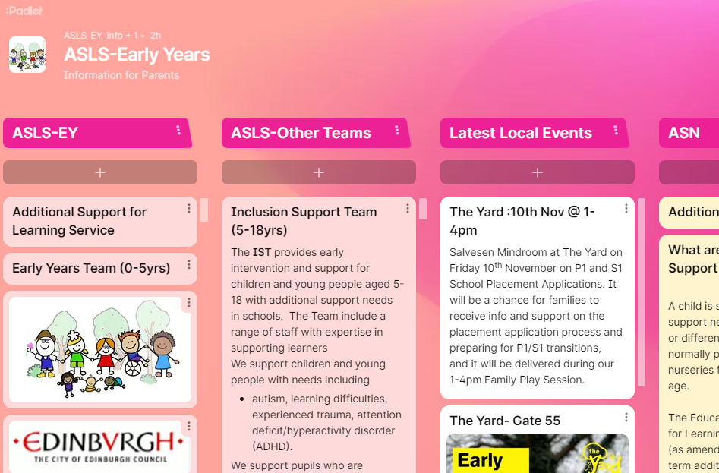 | Click on the link for useful links and information about ASL Services and how we support children with ASN in Edinburgh |   ASLS-Early Years (padlet.com)
Thank you! Excellent!
really helpful, thank you

These sessions are so good. I can’t believe how quickly the time goes!

